C:\Users\brushing\AppData\Local\Microsoft\Windows\Temporary Internet Files\Content.IE5\9T0RFIFK\MC900237319[1].wmf

**Employment Law**

**Legal Update & Mini Workshop**

Staying on top of the legal issues that impact your employment practices is the key to minimizing and preventing workplace claims. This half-day presentation will guide you through the latest court decisions, top employment news and trends, while providing practical guidance and best practices to help you manage your workplace and mitigate your legal risks.



**Hosted By:**

**3.0**

credits pending

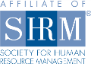

**This program is pending certification for 3 (HR (General) recertification credit hours toward PHR, SPHR and GPHR recertification through the HR Certification Institute**

**Presented By:**

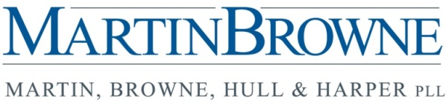

Date: **Tuesday, August 23, 2016**

Place: **Marriott, 100 S. Fountain Ave, Springfield, Ohio 45502**

Cost: **SHRMA Members: $30**

**Non-SHRMA Members $40**

Seminar Schedule:

**7:30 Registration and Full Breakfast (included in cost)**

**8:00 Case Law Review**

**8:45 New Overtime Rules**

**9:30 Break**

**9:45 Political Climate: How the 2016 election could impact employment law**

**10:30 Case Study EEOC and NLRB conflicts**

**11:15 Questions & Final Wrap Up**

To reserve your seat, please register online at [www.springfieldshrma.org](http://www.springfieldshrma.org).